My Story: Falling Down
Mike Long
Entering the 2000 Magic World Championships, I was riding an exciting streak. Though I had skipped more events than I had attended, I had been fortunate enough to either the Top 8 or the finals in five of the last ten premier events I had actually attended. I was also coming off of my first and only suspension (a one month ban for "insufficient randomization") and a pair heartbreaking defeats at U.S. Nationals.

It seemed like a daunting task of trying to get back on track in, of all places, the World Championship. Just as U.S. Nationals had seemed to be my guardian angel throughout my career, Worlds was a tempting frustrating and finally unattainable prize. In five years of competition I had never made a Top 8, while enduring a confusing series of accidents and poor choices. I wasn't really sure which would continue, my streak of good finishes or the much more ominous trend of shoddy luck.
Still, things started off promisingly enough as I compiled a 9-3 record over the first two days, going 4-2 with a "Counter-Tinker" deck and 5-1 in the Limited portion of the tournament. This put me in a decent position to make Top 8 as I needed only to go 4-2 or at very least 3-2-1 with a little luck to finally make Top 8. As I went back to my hotel with my friends I found out my task would be a bit more difficult than I had imagined.
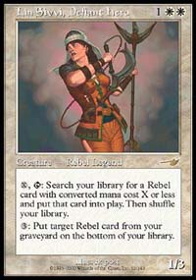
With Lin Sivvi banned, Masques Block Constructed took quite a turn.
The final format was to be Masques Block Constructed, which I hadn't played since PT-NY several months beforehand. Prophecy had been introduced and Lin Sivvi and Rishadan Port had been banned, but much worse, it had been a recent PTQ format. This left me way out of the loop as inventive players all over the world worked furiously to build new decks or improve on old ones. I'm not always the best at staying on top of tournament reports, and even if I were, it's a difficult task to figure out if a deck that won a QT in Kansas is better than one that won in Paris.
The five of us hashed through decks all that night. When I awoke the next morning I still didn't know what I would play. I arrived back at the tournament center with a green-black deck, but would change at the last moment when the French players introduced me to an aggressive monoblue deck called "Blue Skies". I don't know whether the deck I was to play would have given me a better result or not, but I managed only a 2-4 record. Worse still, when the tournament ended I was at a loss for what I should have played.
Usually when a tournament ends, one can boil the format down to one or two decks that would give you the best chance to beat the rest of the field. This time I simply couldn't. While this might not seem like that big a deal, it was huge to me. It was the first time that I felt completely at a loss for an answer to the simple question: "What is the road to victory?" My unending faith in my ability to win under any condition was shaken.
Pro Tour-New York, the first tournament of the 2000 season was team format again, but Brian Schneider's departure to work for Wizards broke up our team and left me without an important touchstone for Magic strategy. I went in with a thrown together team of Peter Leiher and Steve Cowley. Though we had a somewhat promising start, playing Huey, Ben and Casey, one of the better known teams to a draw in the first round, we ended up not even making the second day.

Instead of playing to win, I was playing not to lose.
What was more frustrating was that, primarily due to a pair of Pro Tours I had skipped the previous year, I was unqualified for the Masters tournament at New York. I played in the Gateway but was ignominiously eliminated by Patrick Mello in the first round.
I got my final shot at the Masters series in Chicago, where the rating that I had built up in Masques Limited gave me a berth in the Invasion draft. I built what looked like a very aggressive green-red-white deck and managed to get past Warren Marsh first round.
Second round I faced Dave Williams whom I knew had been working very hard on his game in the last year or so. What made matters much worse was a deck check at the beginning of our match. As soon as the judges took our decks I felt my heart fall into my stomach. Though both David and I had thoroughly shuffled my deck and I had scrupulously registered my deck I still felt like irrationally pleading with the judges to simply allow me to concede and leave with the prize money I had earned. The deck check took about 15 minutes but it felt like forever.
They returned our decks without incident, but the damage was done and I played a meek game, devoid any sort of passion or gamesmanship, to an 0-2 loss.
The Pro Tour was no different. I was tentative throughout. Instead of playing to win, I was playing not to lose. Whether "lose" meant the match, or whether it meant much more, I wasn't sure. I played a pretty innovative deck, a white "Fires" variant, but did so vacantly. I lost more than one game to overcautious play, finally losing in the last round to Joe Weber's "Blue Skies" deck when I inexplicably failed to cast two Parallax Waves (or anything else) in my hand for two consecutive turns while he simply beat me to death with fliers.

[Rosewater] asked me to his room where he and his wife were tending to their new baby, and told me that I needed to get my priorities straight.
When the time came for the Magic Invitational balloting I was totally unaware, not finding out that I had missed the cut by a couple of votes. I didn't even vote for myself. I ended up sliding in as an alternate for the second time in five years when Kyle Rose passed on his invitation. I was happy to be going to Australia for the first time, and hoped that a nice, low pressure tournament might be just what the doctor ordered to get my head straight.
Instead the invitational turned out to be more of the same. I got in trouble right away when Trevor Blackwell and I showed late to the players meeting when we ended up caught in a storm in the middle of Sydney and unable to get through traffic to get back to the hotel in time. Event organizer Mark Rosewater pulled me aside and issued a stern warning, which I tried to take seriously.
Later in the event my fiancé whom had come along to do some sightseeing came down with a case of food poisoning, which would force her to spend most of the rest of the trip in her hotel room. I spent whatever time I wasn't playing caring for her. When the event was mercifully over (I lost more matches in that Invitational than I had in my first three!) and I had taken care of my gunslinging responsibilities, I hurried back to my room.
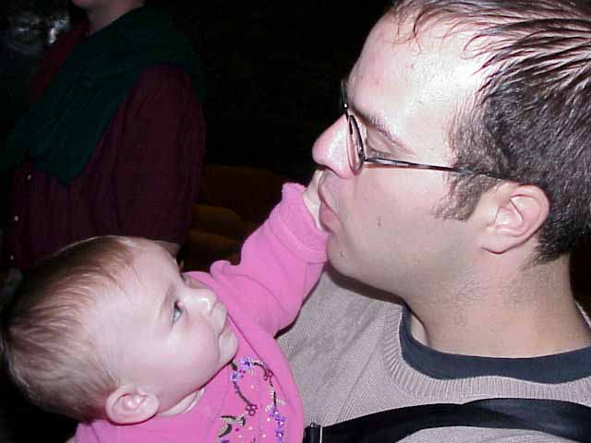
Mike deals with Rachel Rosewater.
I returned to the event site too late to make an awards ceremony they held at the end. I wrote an explanation, apologizing to Rosewater for my absence. He asked me to his room where he and his wife were tending to their new baby, and told me that I needed to get my priorities straight. Rosewater later informed me that I would not be included on the 2001 Invitational Ballot.
I returned to Los Angeles later that year for the Pro Tour where I had enjoyed a lot of success, making Top 8 in both of the last two years, in Limited, which I felt was my strongest format. I practiced hard, as I wondered if I could endure another poor finish. Unfortunate once again my drafts were uninspired and my luck wasn't much better and I failed once again to make second day, as I lost in the last round of the first to Bruce Cowley.
Pro Tour-Tokyo and Barcelona both seemed to blend together into one frustrating tournament for me. I played a black-red beatdown deck in Tokyo and managed only a 4-3 record. Barcelona was worse, as I was blanked in the first draft, going 0-4, mercifully ending my pro season.
In three PTs I had managed just four wins, not enough to make Top 32 in one tournament! What was worse was that my DCI rating that I had built while playing only sparingly over the previous two seasons was gone. After an abortive effort at a 500+ person Mid-Atlantic regional, I found myself a the surprising position of being entirely unqualified for any event, including my best, U.S. Nationals later that summer.

